To upgrade the HMI TP700 firmware from 17.0.0 to 17.0.7 follow the steps

1. Open Simatic ProSave on PC
2. Select the HMI TP700 from the dropdown menu
3. Select the connection type PN/IE (not ethernet)
4. Go to OS Update tab and select the firmware
5. The firmware file can be found in the following path: C:\Program Files\Siemens\Automation\Portal V17\Data\Hmi\Transfer\17.0\Images\CP_7_9\CP_7_9_12_V17_0.fwf
6. This file can also be found on this location

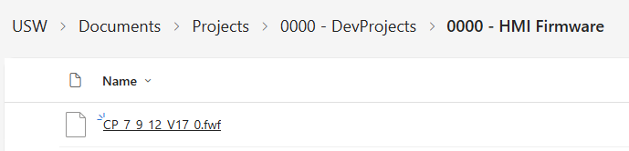

1. Click on the update os button